1. Git init

1. git clone

1. git status

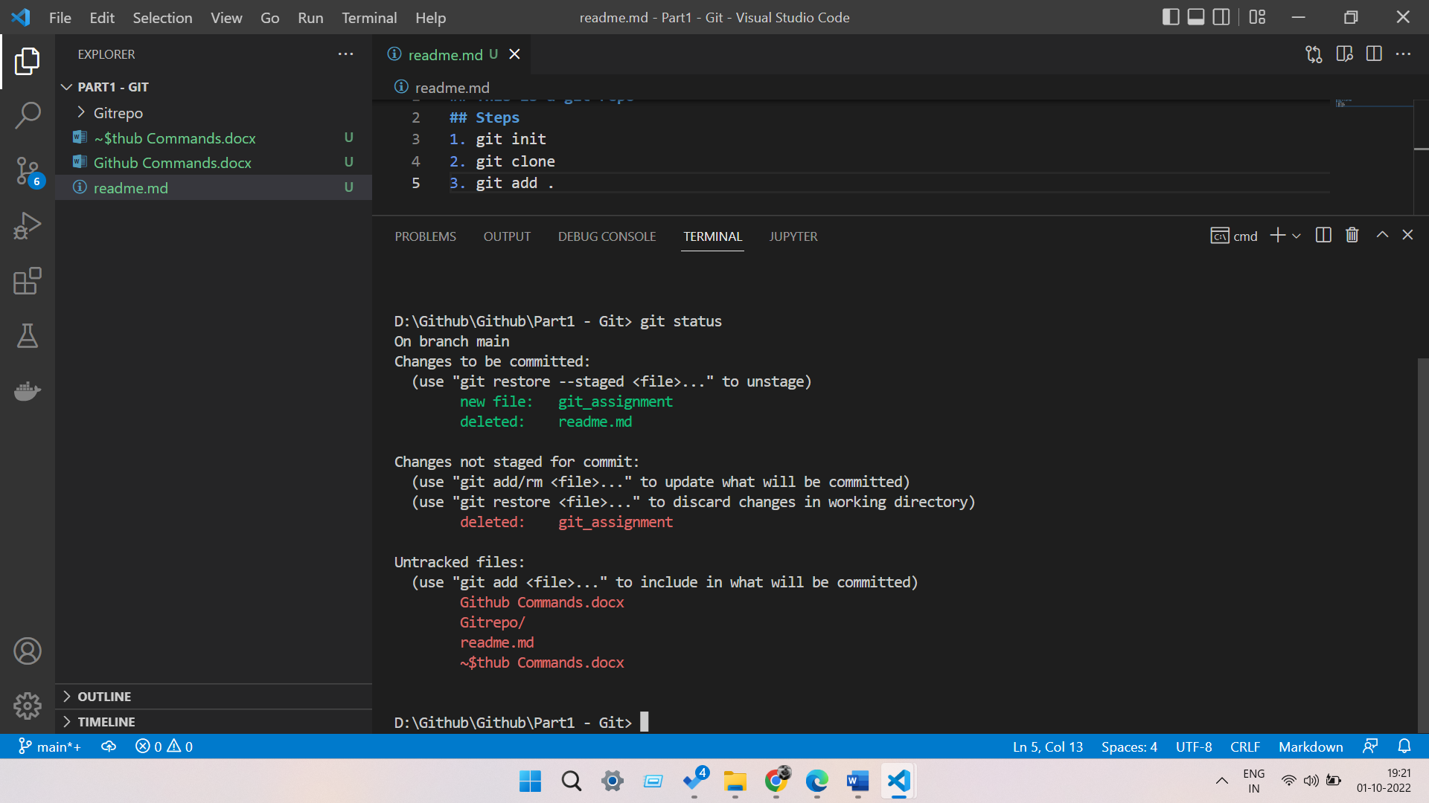

1. git add .

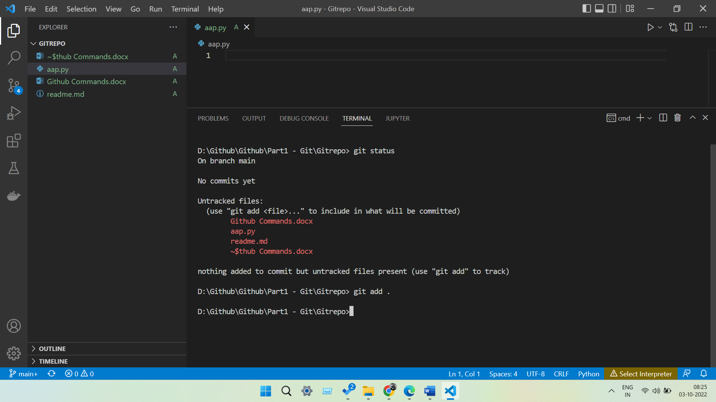

1. git commit

1. git branch

1. git push origin main

1. git branch new_branch

1. git checkout new_branch

1. git commit –amend

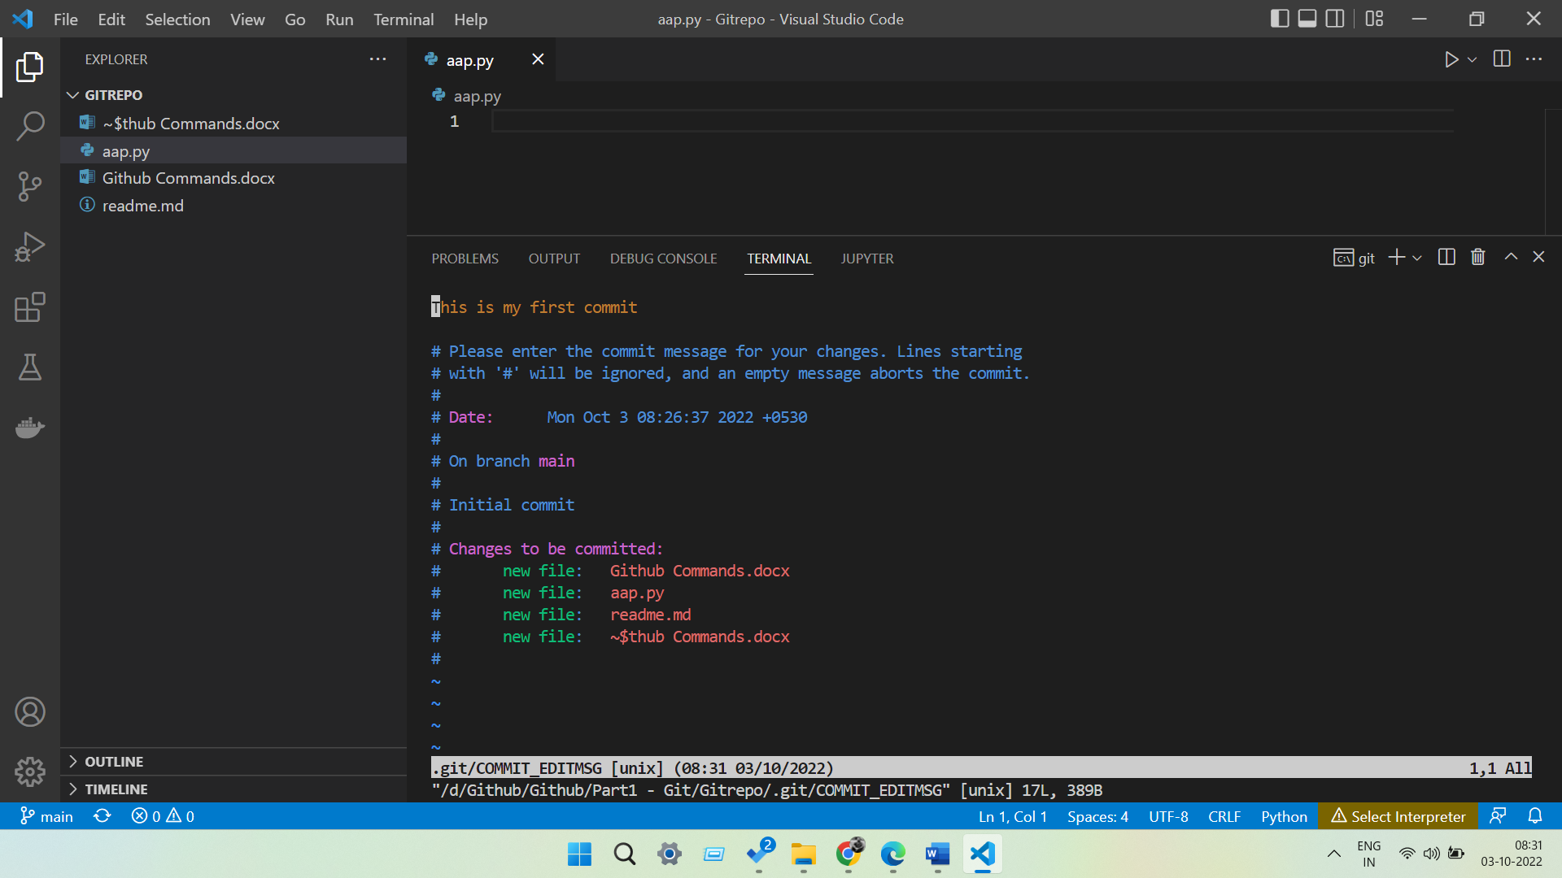

1. git log

1. git merge